Jenkins Assignment -01

Step 1 :- launch Ec2 instance (with 8080 port in security group inbound rule )
Step 2 :- connect to browser open terminal
Step 3 :- Install java
Step 4 :- Install Apache Tomcat 10 (cd /mnt Server) and Give the 777 permission
Step 5 :- go inside /webapps install Jenkins war file
Step 6 :- start the apache tomcat ./startup.sh
Step 7 : - Access the jenkin using public ip http://public-Ip:8080/jenkins/
Step 8 :- it will give the GUI and Ask the password copy the path and copy that password and paste then install the suggested plugins then we are able to create the job
Step 9 :- create the job with execute shell
Following commands 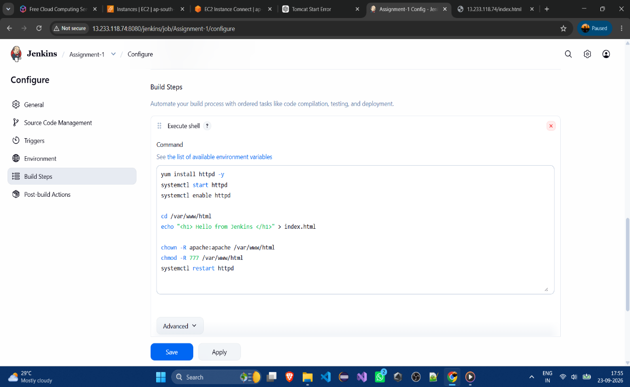

Step 10 :- Apply and save and build the job
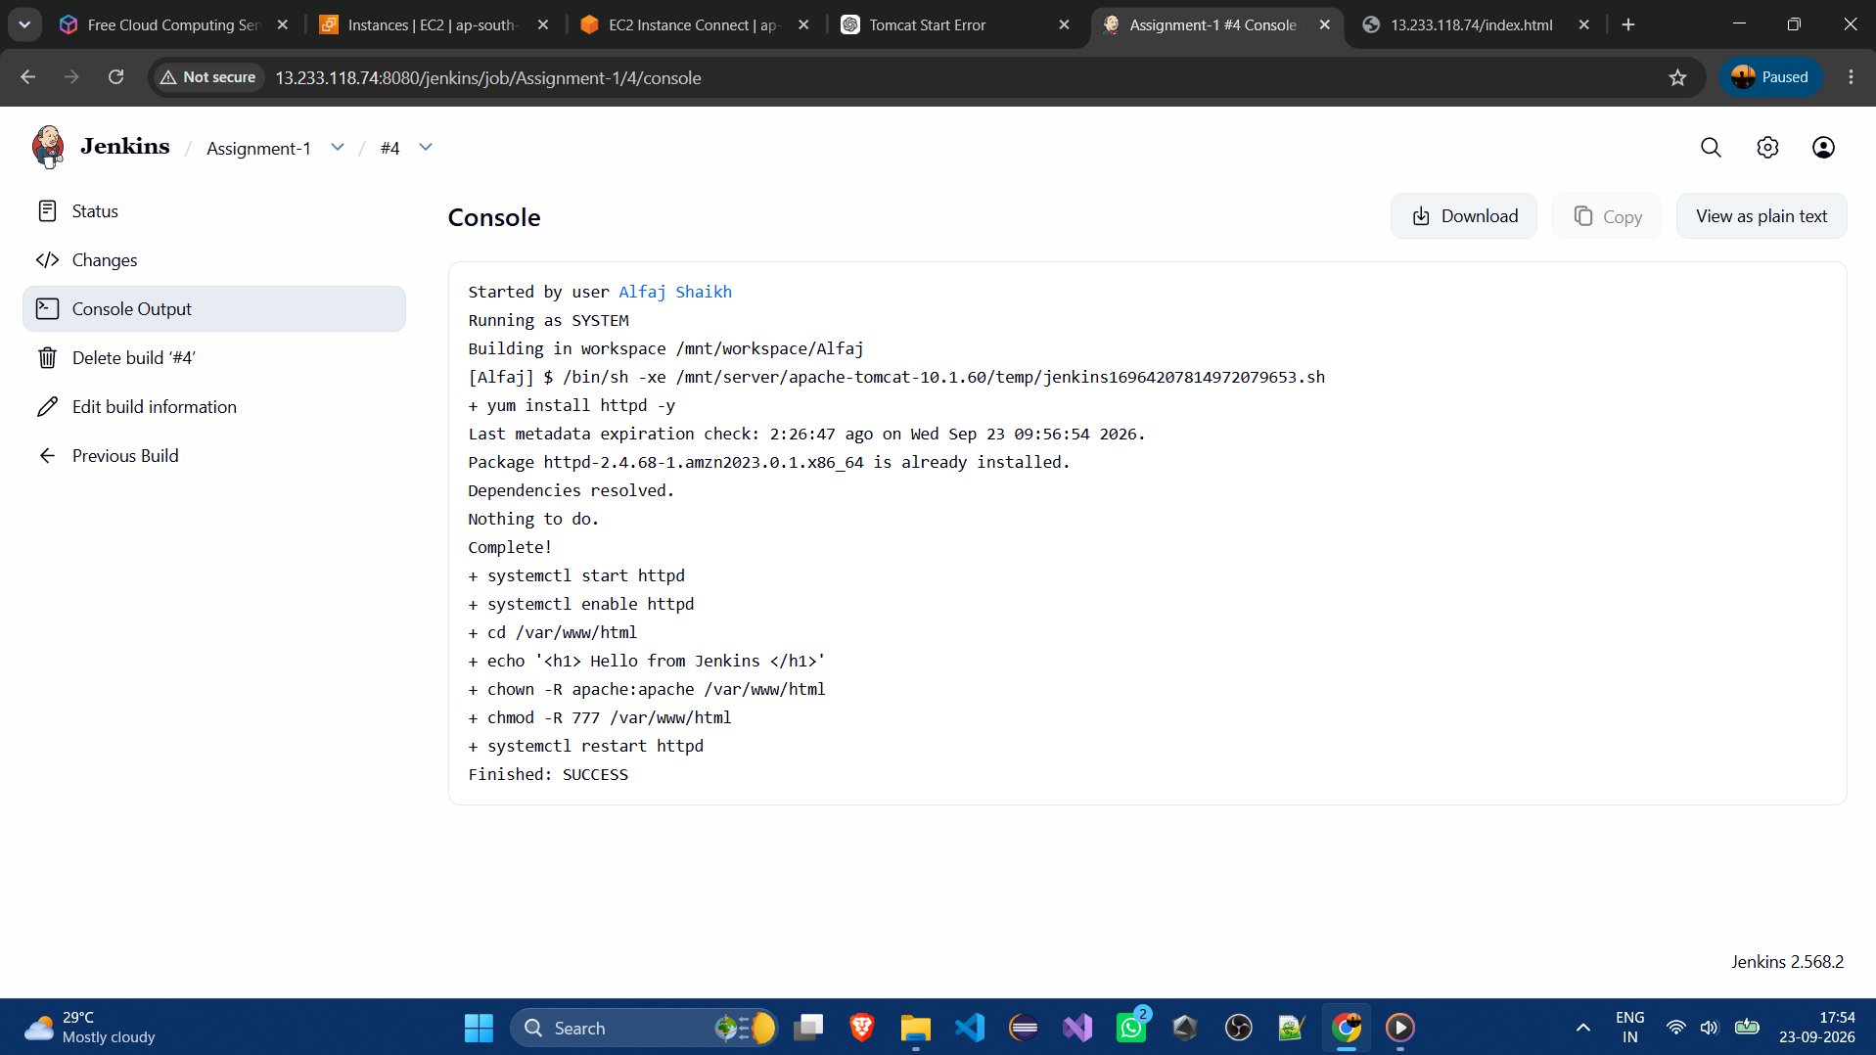
Step 11:-Access the url httpd://pub-ip:80/index.html
